

**Will be holding COVID Vaccination clinics at The Steam Museum,**

**Fire Fly Avenue, SN2 2EY.**

**Brunel Health Surgeries include:**

* **Ashington House Surgery**
* **Carfax Medical Practice**
* **Eldene Surgery**
* **Elm Tree Surgery**
* **Great Western Surgery**
* **Kingswood Surgery**
* **North Swindon Practice**
* **Park Lane Surgery**
* **Phoenix Surgery**
* **Ridge Green Medical Centre: Freshbrook Surgery, Ridge Green Surgery**
* **Ridgeway View Family Practice,**
* **Sparcells Surgery**
* **Victoria Cross Surgery, Eldene Health Centre**
* **Westrop Medical Practice: Highworth, Hermitage, Blunsdon, Taw Hill**

**CORONAVIRUS Vaccine**

A Coronavirus (COVID-19) vaccine developed by Pfizer/BioNTech has been approved for use in the UK.

The vaccine has met the strict standards of safety, quality and effectiveness set out by the independent Medicines and Healthcare products Regulatory Agency (MHRA).

Although other vaccines are being developed they will only be available once they have been thoroughly tested to make sure they are safe and effective.

**Vaccine Safety**

Any vaccine including the coronavirus vaccine must go through all clinical trials and safety checks which all licensed medicines have to go through. The UK has some of the highest safety standards in the world.

Vaccines will only be used if they are approved by the MHRA. The MHRA has been monitoring every stage of the coronavirus vaccine development.

**Who will get the vaccine?**

We will contact all patients when they become eligible for the coronavirus vaccine.

**Our clinics will be held at the STEAM Museum. This will be for patients from the surgeries connected with Brunel health Group**

**Information for Patients**

Once we have contacted you and booked your appointment in the COVID vaccination clinic, please ensure that you arrive for your appointment at your allocated time slot so we can ensure social distancing measures are in place.

Please arrive on your own or with one other person if you require support.

If you are arriving by bus. The nearest main bus stop is Dean street/ Church Place. From here you can walk to the STEAM Museum through the tunnel just passed the Bristol street carpark.

We are asking all patients to wear a face covering. This is to not only protect yourself but others around you. We are also asking patients to wear loose fit clothing that is easy to remove so that we are able to see you in a timely manner. Please do dress in warm clothing, as there may be a queue but this is usually fast moving and we have several clinicians that are working in the building.

Car parking

Fire Fly Avenue

The Steam Museum

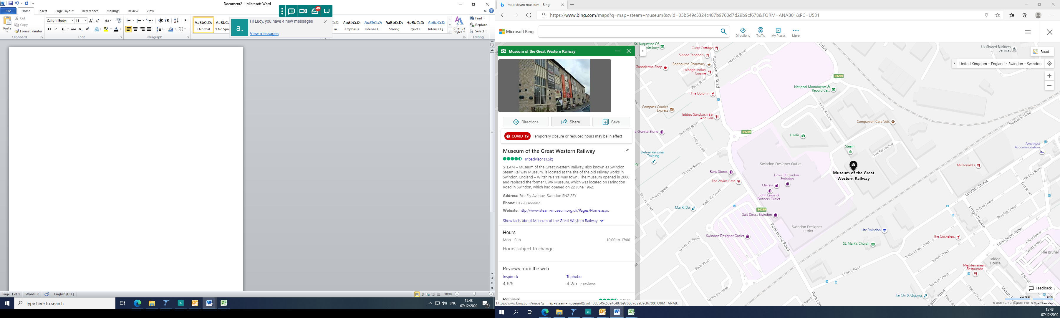

Blue Badge holder car parking

**From Highworth (20 minutes 7.4Miles approx.)**

* Head south-west on A361/Lechlade road towards High street (0.1 mile)
* Pass through 4 roundabouts, remaining on A361
* At the roundabout take 1st exit on to B4006/Highworth road
* Pass through 4 roundabouts, remaining on b4006
* At roundabout, take 2nd exit on to B4143 / Bridge End Road
* Pass through 2 roundabouts, remaining on B4143
* At roundabout, take 1st exit on to A4311 / Cirencester Way
* At roundabout, take 2nd exit on to B4289 / Great Western Way
* Pass through 4 roundabouts, remaining on B4289
* Turn left to stay on B4289 / Kemble Drive
* At roundabout, take 2nd exit
* Park in the second Carpark and you will need to walk down Fire fly Avenue
* Bear left and you will see the STEAM Museum.

**From Shrivenham (22 Minutes, 7.9 Miles approx.)**

* Head south-east on B4000 / Highworth Road toward The Green
* Keep right to stay on B4000 / Townsend Road
* Bear right on to Townsend Road
* Bear right and then turn left on to A420
* At roundabout, take 2nd exit
* At roundabout, take 3rd exit on to A4312 / Oxford Road
* At roundabout, take 4th exit on to B4006 / Swindon Road
* At roundabout, take 1st exit on to B4143 / Bridge End Road
* Pass through 2 roundabouts, remaining on B4143
* At roundabout, take 1st exit on to A4311 / Cirencester Way
* At roundabout, take 2nd exit on to B4289 / Great Western Way
* Pass through 4 roundabouts, remaining on B4289
* Turn left to stay on B4289 / Kemble Drive
* At roundabout, take 2nd exit
* Park in the second Carpark and you will need to walk down Fire fly Avenue
* Bear left and you will see the STEAM Museum